Operational Concept Description (OCD)

Student Scheduling System

Team #06

Douglass Kinnes: Project Manager, Quality Focal Point, Implementation Team member

Alexey Tregubov: System Architect, UML Modeler, Implementation Team member

Mihir Daptardar : Operational Concept Engineer, Quality Focal Point, Implementation Team member

Ihsan Tolga : Life Cycle Planner, Feasibility Analyst, Implementation Team member

Simone Lojeck : IV&V, Shaper, QFP

Version History
Date | Author | Version | Changes made | Rationale
10/03/12 | Alex Tregubov, Mihir Daptardar, Zheng Lu, Doug Kinnes | 1 | Initial Creation of document, filled information known for VC Package delivery. | Created initial document  For VC Package
10/08/12 | Alexey Tregubov | 1.1 | Fixed bugs 7075, 7073, 7080, 7069, 7070, 7072, 7078, 7077, 7068  Updated table of contents  Updated section A1.1 – all missing stakeholders were added.  Updated diagram in section A2.3 | Improved document consistency
10/13/12 | Alexey Tregubov | 1.2 | Added document property – version.  Fixed document formatting defects (footers, headers, styles, section numeration)  Updated section A2.1 (TA comments considered).  Updated sections 3.1.2 and 3.1.3. (TA comments considered). | Improved document consistency (formatting)  Fixed some defects found by TAs  Suggested changes for sections 3.1.2 and 3.1.3.
10/15/12 | Doug Kinnes | 1.3 | New diagram for A.2.1.3  Filled in A.2.2, A.2.3, A.2.4 | Improved understanding of current system led to new Business Workflow Diagram  Completed sections needed for capabilities for Core FCP
10/16/12 | Doug Kinnes | 1.4 | Fixed bug 7070, 7077, 7085, 7066, 7073, 7087 | Improved document accuracy and consistency
10/22/12 | Mihir Daptardar | 1.5 | Updated the current worklow (Fig: 3)  Added the element relationship diagram (Fig 4)  Added sections 3.4.1 and 3.4.2 | Detailed current workflow
10/24/12 | Doug Kinnes | 1.6 | Fixed Bugs 7073, 7077 | Added paragraph to Shared Vision
10/29/12 | Alexey Tregubov | 1.7 | Fixed bugs: 7073, 7077, 7085, 7086, 7082, 7407, 7319, 7407, 7408, 7409, 7410, 7411, 7413, 7415, 7416, 7417, and 7418. | Fixed defects pointed out by TA.
10/31/12 | Alexey Tregubov | 1.8 | Element relationship diagram and current business workflow were updated. | Diagrams were updated according to the recommendations given by TA.
11/3/12 | Mihir Daptardar | 1.9 | Study Plan component in Figure 4 had the spelling mistake. | Updated the diagram according to the defects pointed in the ARB.
11/14/12 | Alexey Tregubov | 2.0 | Fixed defects: 7587, 7588, 7589 | Headers were properly formatted.
11/26/12 | Mihir Daptardar | 2.1 | System boundary (Figure 2) needed to be more precise | Updated the support infrastructure in the system boundary diagram
12/07/12 | Alexey Tregubov | 2.2 | Fixed defects: 7917 and 7918 | Updated version and current status of the document.
04/26/12 | Mihir Daptardar | 2.3 | Fixed defects: 8163, 8208, 8209 and 8210 | Updated version, footer, name and removed team member

Table of Contents
Operational Concept Description (OCD) i
Version History ii
Table of Contents iv
Table of Tables vi
Table of Figures vii
1. Introduction 1
1.1. Purpose of the OCD 1
1.2. Status of the OCD 1
2. Shared Vision 2
2.1. Benefits Chain 3
2.2. System Capability Description 3
2.3. System Boundary and Environment 4
3. System Transformation 5
3.1. Information on Current System 5
3.1.1. Infrastructure 5
3.1.2. Artifacts 5
3.1.3. Current Business Workflow 6
3.2. System Objectives, Constraints and Priorities 6
3.2.1. Capability Goals 6
3.2.2. Level of Service Goals 7
3.2.3. Organizational Goals 7
3.2.4. Constraints 7
3.2.5. Relation to Current System 7
3.3. Proposed New Operational Concept 8
3.3.1. Element Relationship Diagram 8
3.3.2. Business Workflows 9
3.4. Organizational and Operational Implications 10
3.4.1. Organizational Transformations 10
3.4.2. Operational Transformations 10

Table of Tables
Table 1: The Program Model 2
Table 2: Artifacts 5
Table 3: Capability Goals 7
Table 4: Level of Service Goals 7

Table of Figures
Figure 1: Benefits Chain Diagram of Student Scheduling System 3
Figure 2: System Boundary and Environment Diagram of Student Scheduling System 4
Figure 3: Current Business Workflow 6
Figure 4: Element Relationship Diagram 8
Figure 5: Business Workflows Diagram 9

Introduction

Purpose of the OCD
This document describes the shared visions of the success-critical stakeholders of the project, Student Scheduling System. This project will be used by Stevens Institute of Technology Computer Science Department. The main success-critical stakeholder is Professor David Klappholz who is the project owner and adviser at Stevens. All other success-critical stakeholders include:
- Undergraduate students of Stevens (undergraduate CS, IS, and CyS majors)
- Course directors
- Advisers
- Administrators
- Software maintainers
- Developers
This OCD will be used constantly throughout the project’s life cycle as developing on the new operational concepts.

Status of the OCD
The status of the OCD is the version in the transition phase. This document gives our current understanding of the project within the transition phase. All sections are complete and finalized.

Shared Vision
The vision for this system is to create an easier and less complicated way for students to be able to create schedules in order for them to graduate in the time frame they desire. As shown in Table 1, this is achieved by the system being planned with the cooperation of Steven's Institute staff, faculty and students.
Table 1: The Program Model
Assumptions:
- Students and advisor will use the new system.
- Available courses and degree requirements will be kept up to date.

Stakeholders | Initiatives | Value Propositions | Beneficiaries
- Developers  - Undergraduate students of Stevens (undergraduate CS, IS, and CyS majors)  - Course directors  - Advisers  - Administrators  - Software maintainers | - Deliver the system.  - Fill the data base with initial data.  - Inform new students about the systems.  - Hold training sessions for students.  - Move server from USC hosting to Stevens hosting and maintain the server.  - Enhance the system. | - Save advisers’ and students’ time  - Reduce students’ frustration  - Reduce number of mistakes in a schedule made by students | - Stevens’ students (undergraduate CS, IS, and CyS majors)  - Stevens’ advisors (undergraduate CS, IS, and CyS majors)

Benefits Chain
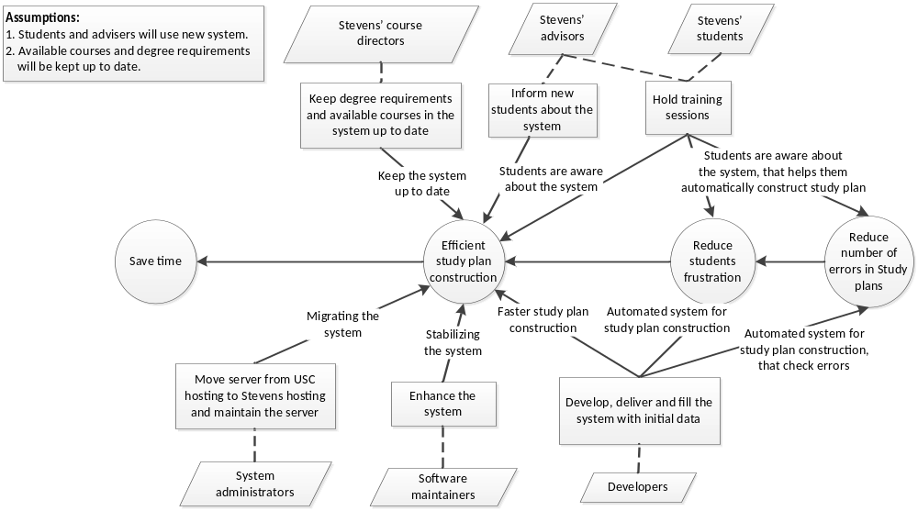
Figure 1: Benefits Chain Diagram of Student Scheduling System

System Capability Description
Student scheduling system is a web information system which main purpose is to save students’ and advisers’ time construction study plans. Today this process takes a lot of time, sometimes up to 1-2days. The System intends to solve this problem by automating the construction of the study plan. Course directors and advisers of Stevens Institute of Technology Computer Science Department, which is the customer of the system, will benefit from using this system because it will reduce frustration of their students and save great deal of their valuable time.
Most of the existing solutions such as Rutgers University Course Scheduling System and Student Class Scheduling by College Scheduler LLC are usually aimed to construct class schedule not course scheduling for study plan. Even those systems which provide such capabilities for students are very limited in functions specific for certain university. From that prospective Student scheduling system for Stevens University is quite unique. Moreover, most of the existing solutions that can potentially solve similar task are commercial and quite expensive.
The distinguishing features of the Student scheduling system for Stevens University are the following:
- The System will allow course administrators to specify wide range of degree requirements for a specific program (Computer Science, Cyber Security) through the web user interface,
- Students will be able to enter constraints for their study plan (such as preferred courses, semester of graduation, etc.)
- Students will be able to construct the study plan satisfying the degree requirements and their desires.
Unique feature of the system is that it will consider all possible types of degree requirements which exist in Stevens University. Existing competitors does not provide enough flexibility to cover all the cases of degree requirements in Stevens University.

System Boundary and Environment

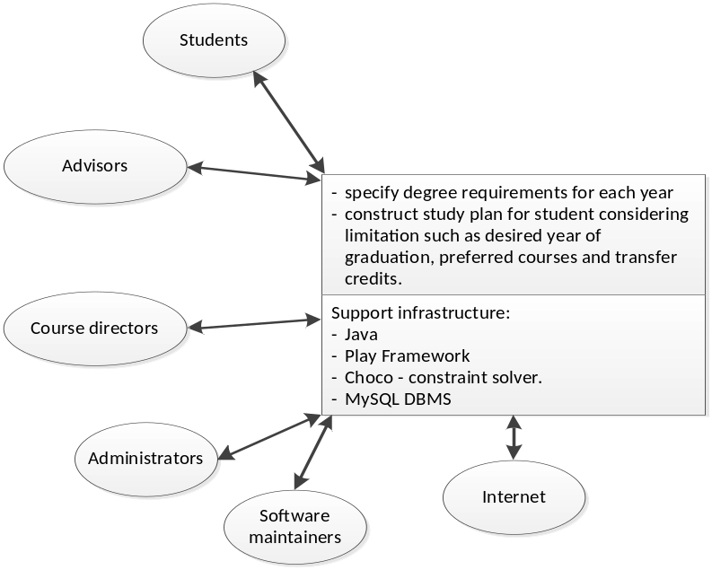
Figure 2: System Boundary and Environment Diagram of Student Scheduling System

System Transformation

Information on Current System

Infrastructure
- No current system exists.
- All the scheduling and course planning are done manually by advisors with students.
- If the students cannot find schedule that satisfies their desires on their own, they ask their advisor to help them in study plan construction. That part of the process consumes a lot of time.

Artifacts
Current process is manual, and it uses the artifacts provided in Table 2.
Table 2: Artifacts
# | Artifact | Description
1 | Description of the degree requirements. | Description is available in a set of documents, which contain list of mandatory courses, and rules that describe how elective courses can be selected.
2 | Recommended sequence of courses for students. | For freshmen students, who do not have transfer credits or other individual requirements, university provides recommended sequence of courses to be taken for each degree. That helps such students to fill in study plan without spending a lot of time.
3 | List of the courses available on the department website. | Plan unstructured list of available courses and general information about them (semesters when it is offered, instructors, etc.) is provided on the website.
4 | Study plan template with list of mandatory courses. | Study plan template is a document that students have to fill in and submit to the department.

Current Business Workflow
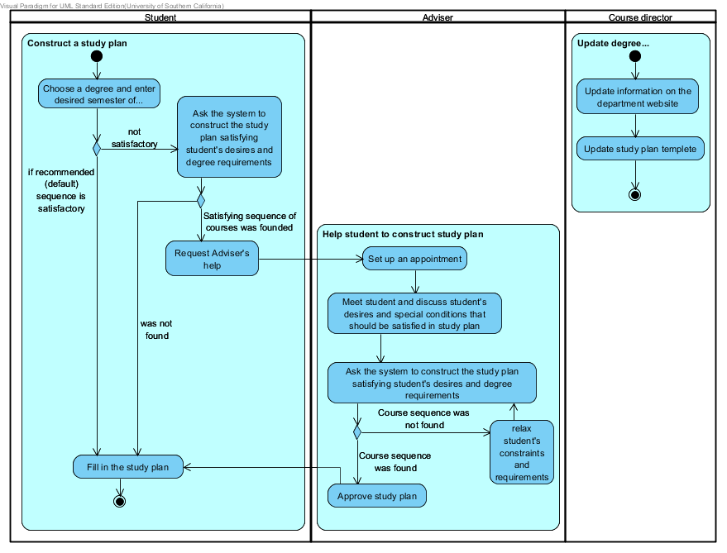
Figure 3: Current Business Workflow

System Objectives, Constraints and Priorities

Capability Goals
Table 3: Capability Goals
Capability Goals | Priority Level
OC-1 Schedule Construction: The system calculates the best possible study plan (if it exists), which satisfies student’s desires and degree requirements. | Must Have
OC-2 Degree Requirements Input: The system allows course director to enter degree requirements as complex as all existing requirements including those which were used in previous years. | Must Have
OC-3 Student’s constraint’s input: The system allows the student to enter all necessary desires for study plan, such as semester of graduation, preferred elective courses, transfer/obtained credits, and etc. | Must Have

Level of Service Goals
Table 4: Level of Service Goals
Level of Service Goals | Priority Level | Referred WinWin Agreements
LOS-1 Returned Results: System will return results in a response time in the same order of its algorithms complexity | Could Have | WC_1357

Organizational Goals
OG-1: Eliminate frustration of the advisors when creating student schedules.
OG-2: Save time by allowing students to create schedules on their own time.
OG-3: Reduces mistakes in choosing courses.

Constraints
CO-1: No monetary budget.
CO-2: The system must use technological infrastructure that can be maintained by client.
CO-3: The system must calculate study plan faster than it is done manually.

Relation to Current System
There is no automated system now. The process is completely manual. Proposed system intends to save students’ and advisers’ time by eliminating time-consuming activity “Help student to construct study plan” (figure 3).

Proposed New Operational Concept

Element Relationship Diagram
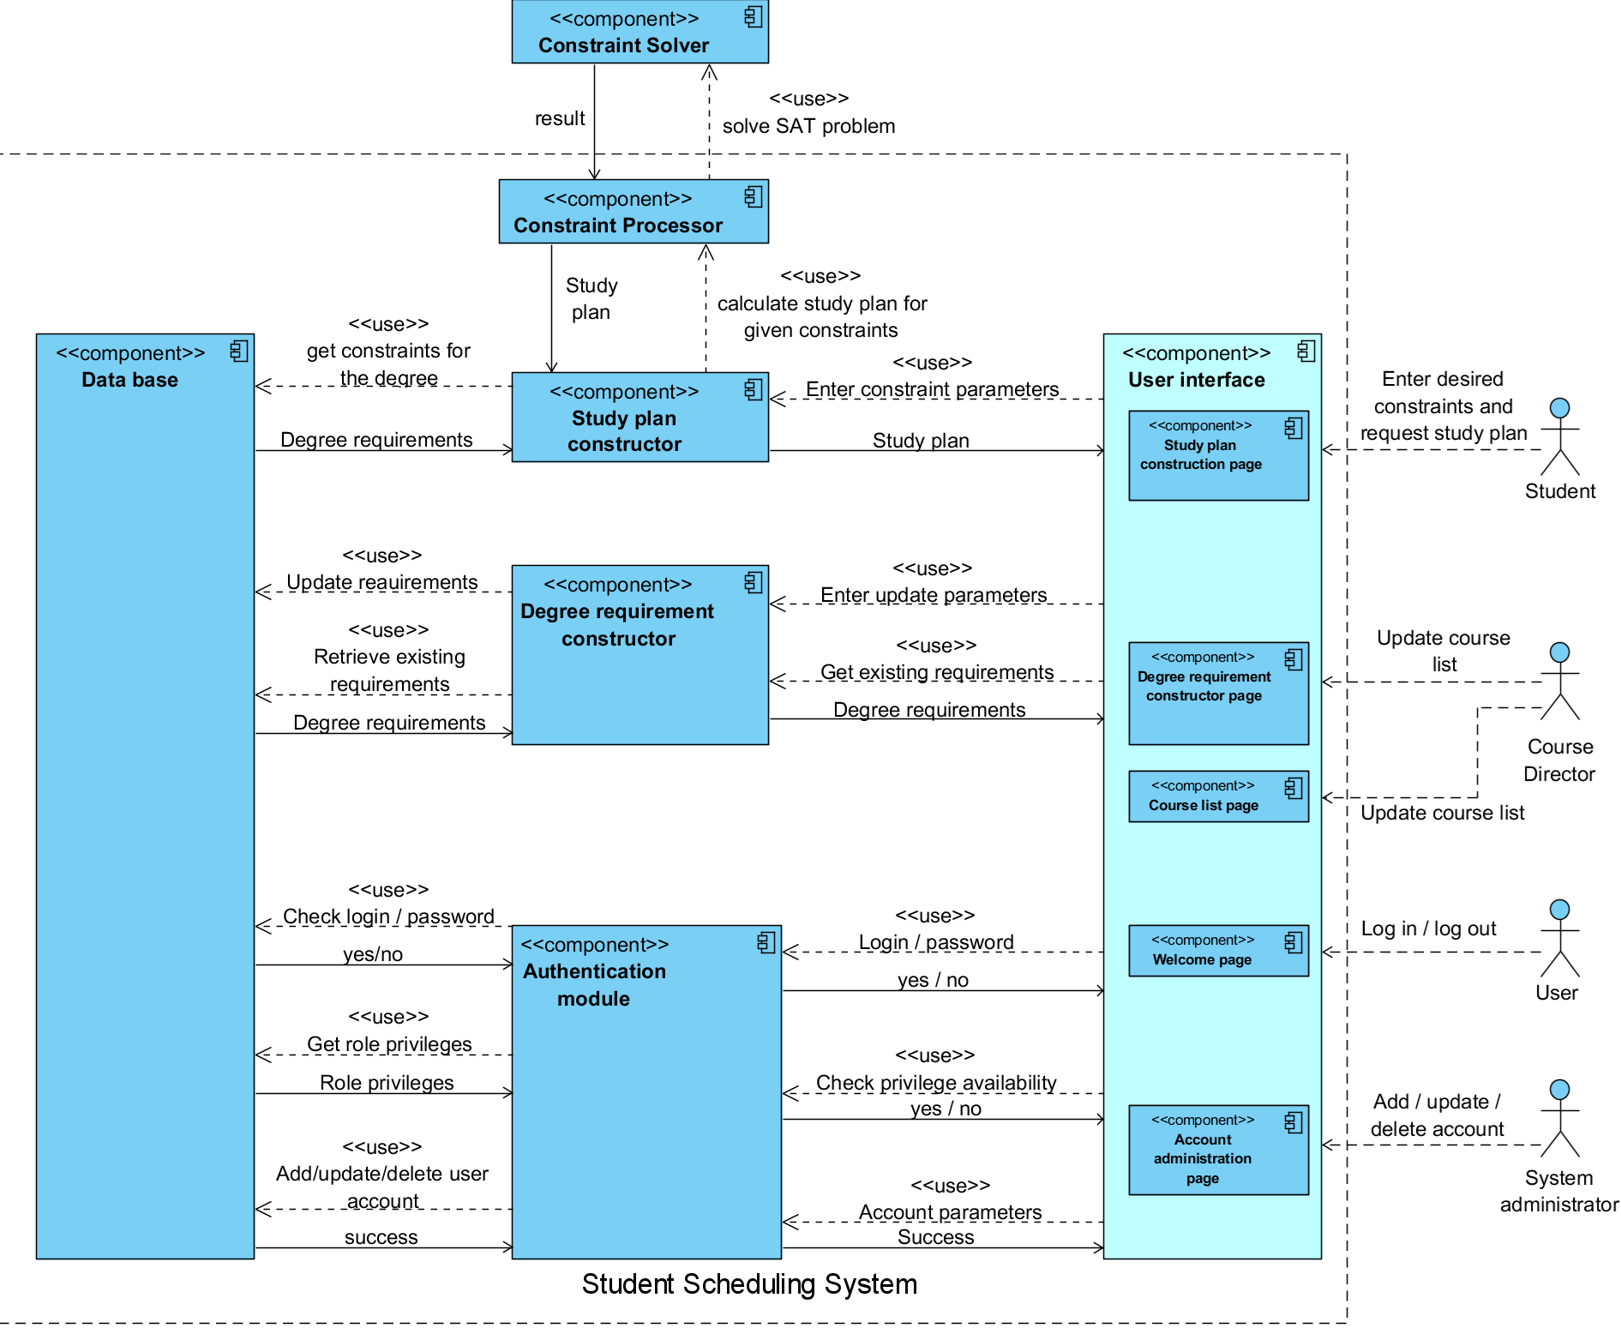
Figure 4: Element Relationship Diagram

Business Workflows
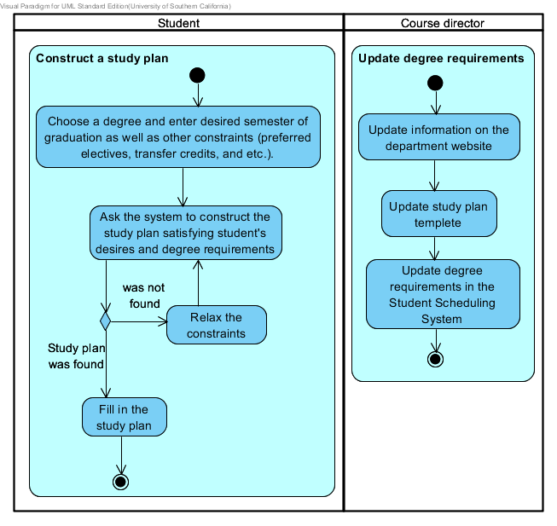
Figure 5: Business Workflows Diagram

Organizational and Operational Implications

Organizational Transformations
- There would be an added responsibility for the current system admin. It is his responsibility to troubleshoot any problems in the system and to make sure that the system is running smoothly.
- The course directors would have to update the degree requirements. This can be as minor as adding or updating a course in the current degree requirement or as major as adding a new degree and its corresponding requirements. They may also authorize any other employee (ex: a student worker, part time employee) to update degree requirements.
- The major stakeholders affected by the changes are system admins, course directors and students
- The new system would save the students’ and advisors’ time. In addition to time saving, there would be a lot less stress for students as well as advisors.
- This would allow students to plan effectively, in terms of their goals other aspects and would help them achieve their aspirations and goals.

Operational Transformations
- There was no earlier automatic system. This automatic system compared to the current manual system would be more robust and efficient.
- With the new system, the student would have the convenience of being anywhere (with a computer and an internet connection) and chalk out a custom schedule with all the desired courses. Also, if there are some changes, in terms of course requirements, he can go back and construct another one with the new changes
- Also, the course director can focus on other high priority activities and get them out of the way. This would result in an increase in productivity.

